**Graph Shows SalePrice Vs GrLivArea**

**Results before selecting the top 15 correlated columns and removing “outliers”**

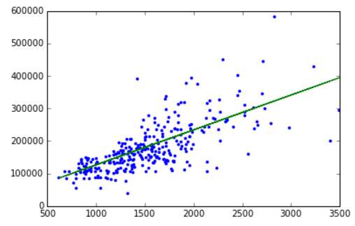

**Results After selecting the top 15 correlated columns and removing “outliers”**

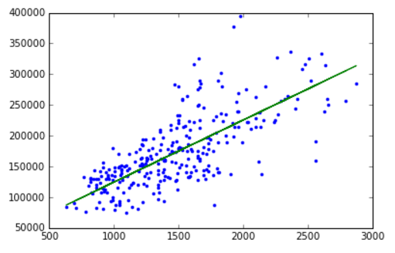

**Root Mean Square Error has reduced from 34190 to 24807**